## Process Model Folder Hierarchy

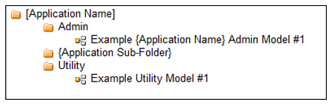

Rules Folder Hierarchy

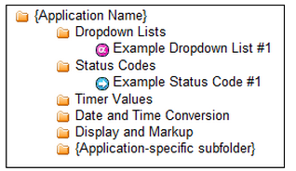

## Document Folder Hierarchy

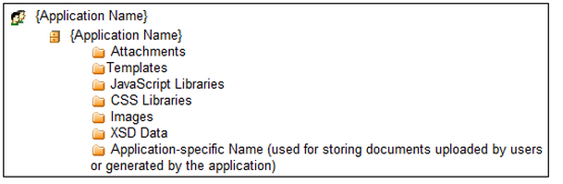

**Recommended Naming Standard**

|  |  |
| --- | --- |
| **Custom Data Types** | VC_ClaimDetails |
| **Variables** | salaryAdvanceAmount_dec |
| **Rules** | HR_ComputeBaseSalary() |
| **Constants** | HR_IMG_CAREER_HISTORY_ICON |
|  |  |